Install Dependencies:

pip install django djangorestframework

**Apply Migrations:**

python manage.py makemigrations api

python manage.py migrate

**Development Server:**

python manage.py runserver

Testing Functionality:

Create users via Django admin or register using API  
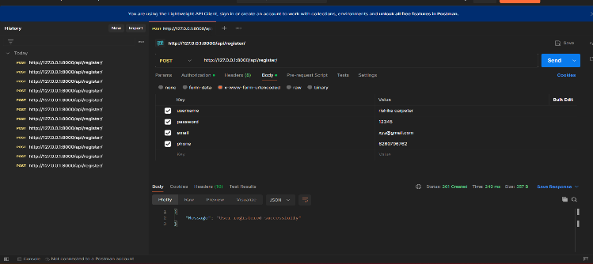

Login using API and generating the Authentication token  
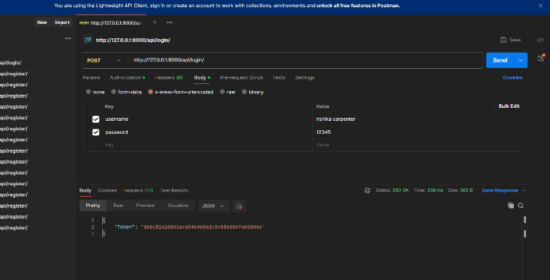

Mark a number as spam (Use the Authentication token)

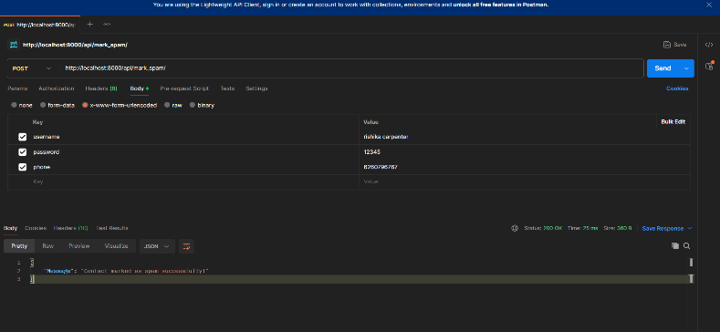

Save Contacts

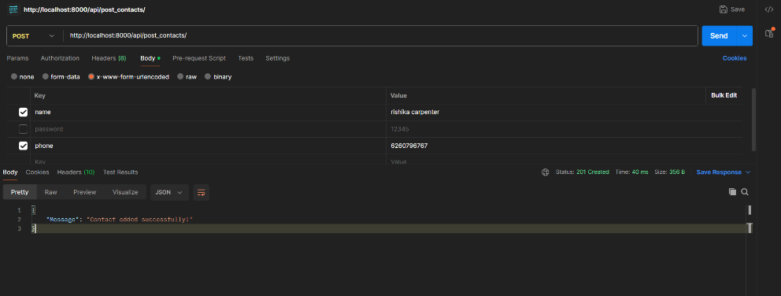

Get Contacts

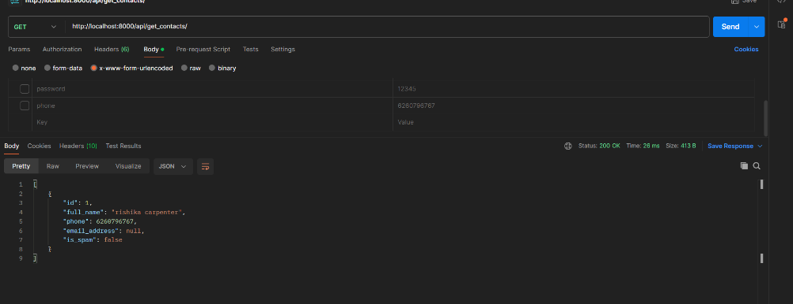

Search by Phone Number

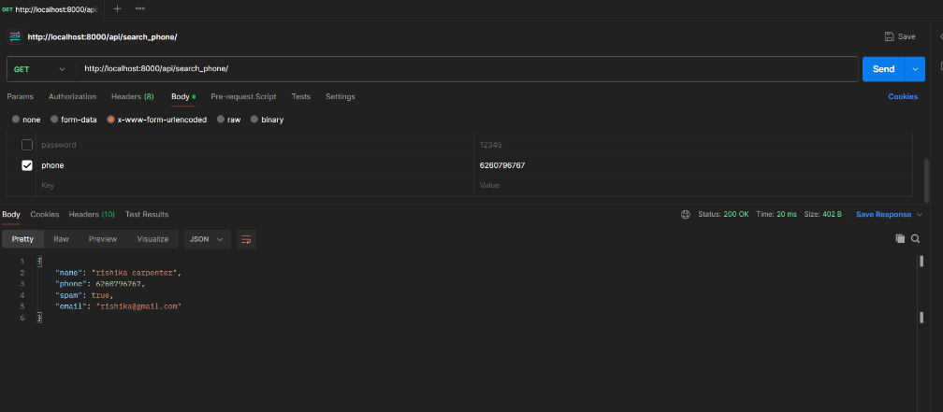

Search by Name

